Bug club phonics: | j,v,w,x  y,z,zz,qu  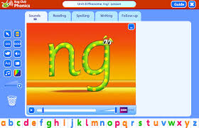  ch,sh,th,ng  Ai,ee,igh,oa,oo long oo short  Ar, or,ur,ow,oi  Ear,air,ure,er |  | Texts: |  | At the same moment around the world  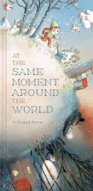  George and the Dragon  If I were an astronaut  Sammy striker and the football cup  Banana man  Supertato  Non fiction jobs past and present  Non fiction emergency services
Not fully decodable words: | 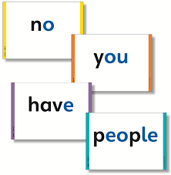  Said, have, like  So, do, some  Come, were, there  Little, one, when  Out, what |  | Oracy and vocabulary: |  | Think about what happened  Explore vocabulary  Listen to and talk about stories to build familiarity and understanding  Engage in non-fiction books  Listen to and talk about selected nonfiction books
Maths: | STEM WEEK  Time  Timers  Clocks  Watches  Days of week  Months  Seasons | 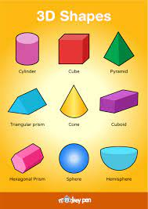  Recognise, name 3d shapes  Find 2d shapes in 3d shapes  Complex patterns  Build numbers 10-14  Complete patterns 10-14  Verbal counting beyond 20  Counting – larger sets and things that cannot be seen  Subitising – to 6, including in structured arrangements  Composition – ‘5 and a bit’  Composition - of 10  Comparison – linked to ordinality  Play track games | Personal, social and emotional deve lopment: |  | Partner and group work  Turn taking  Discussions  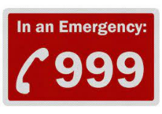  999 and the emergency workers.  What to say to 999  Moral behind story of St George  Bravery  Courage  Challenge  Dreams and goals  Perseverance  Super hero qualities: what makes a someone a superhero
Understanding the world, including people and communities and science: | 999 jobs  Melt the ice experiment.  Changes from baby to child.  How apples change over time.  How long do things take to dissolve in water?  Timer, clocks, alarms  Heroes from the past- ST George Magnets- sorting objects by magnetism  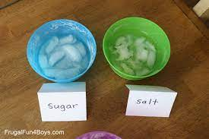  Flying magnetic superhero experiment.  Astronaut jobs.  The 5 senses.  Superhero senses.  Sports jobs  Supehero capes- waterproof and not waterproof.  Properties of materials.  Parents jobs.  Using laptops, computers and tablets to type and research.  Jobs in the local area.  Using laptops, computers and tablets to type and research |  | Expressive art and design: | Make a sand timer  Printing with time and light  Making a clock  Watch designer  Role play  Junk modelling emergency vehicles  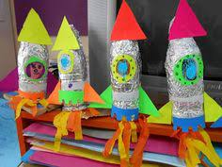  St George’s flag: 3D tissue paper  Shield design  Shield  Small world  Junk modelling space crafts  Astronaut silhouette picture  Space man split pin character  Superhero cape designs  Superhero capes  Football – using a net (maths)  Medal design  Superhero logo  Super hero city landscape picture using newspaper for building outlines  Junk modelling superhero cuffs and jet packs  Superhero masks  Own book cover (linked to library trip)
Fine motor skills focus: | Daily name/CVC/sentence writing activities. Threading, cutting, weaving, playdough, Finger Gym activities. Develop pencil grip and letter formation continually Use one hand consistently for fine motor tasks. Cut along a straight line with scissors / Start to cut along a curved line, like a circle / Draw a cross.

